Manual Squarespace
Start editing click Website since they’re at the top of the menu.
Every page on your website is listed here.
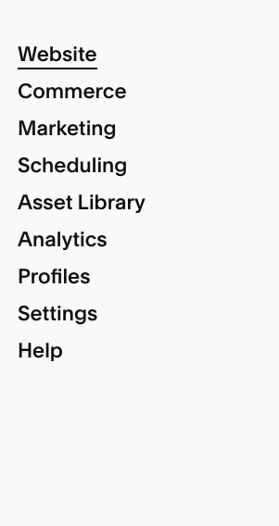
Editing page settings
To edit the Page Settings, roll over the name to find the small gear icon and click it.
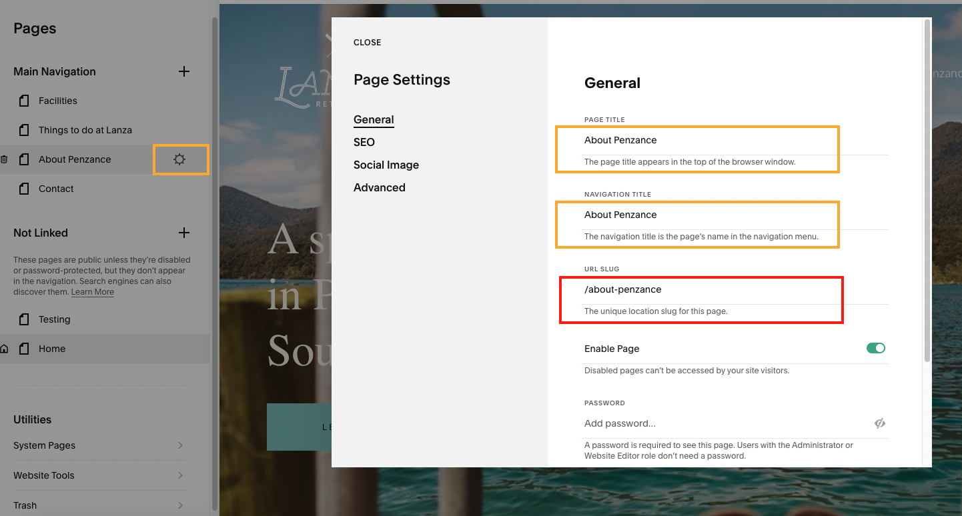

In Page Settings, you can tweak your page title and navigation name and URL. Page Settings are useful if you want to know how to duplicate a Squarespace page. Go to Page Settings → General and scroll down to find the Duplicate Page link. Click on it to duplicate any Squarespace page. I recommend making a duplicate when making a new page. It already copies the correct layout of your website and keeps branding consistent.
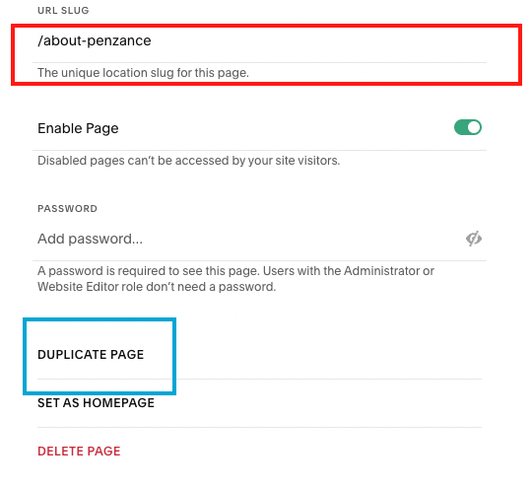
Don’t forget to change the url in url slug after you make a duplicate!

Editing page content
Clicking on the Edit button opens up the editing options for your pages.
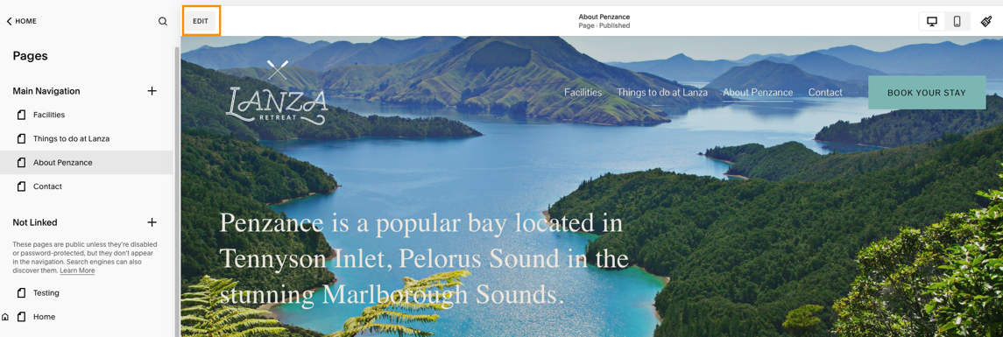

⚠️ One important point, Squarespace doesn’t have an auto-save feature. Generally, it’s hard to navigate away from a page without hitting Save changes. But a lost connection or closed window could cause some trouble.
After making changes click save at the top to publish your changes.
Sections and content blocks
You can change the section and content blocks within your website page. In the example below you see the section. In the section you’ll see there are two text blocks a button and an image.
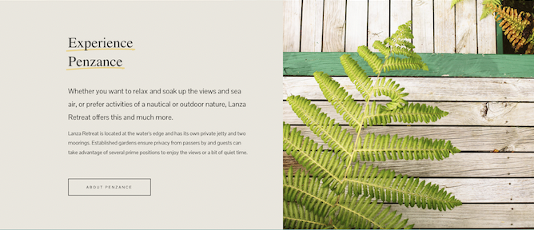
Most of the content areas can be edited, including blocks of text, buttons, and photos.
To change a content block click on the text and click the pencil icon to open the text editor. Here, you can add lists and links, bold text, and more. Simply type in your new text and add any formatting.
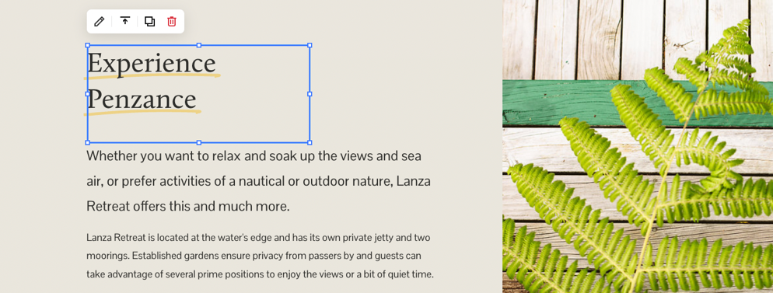
To change the settings of the section click the section (in example below I clicked on the left side next to the text block. Click edit section. Here you can edit the colours and height of the section.
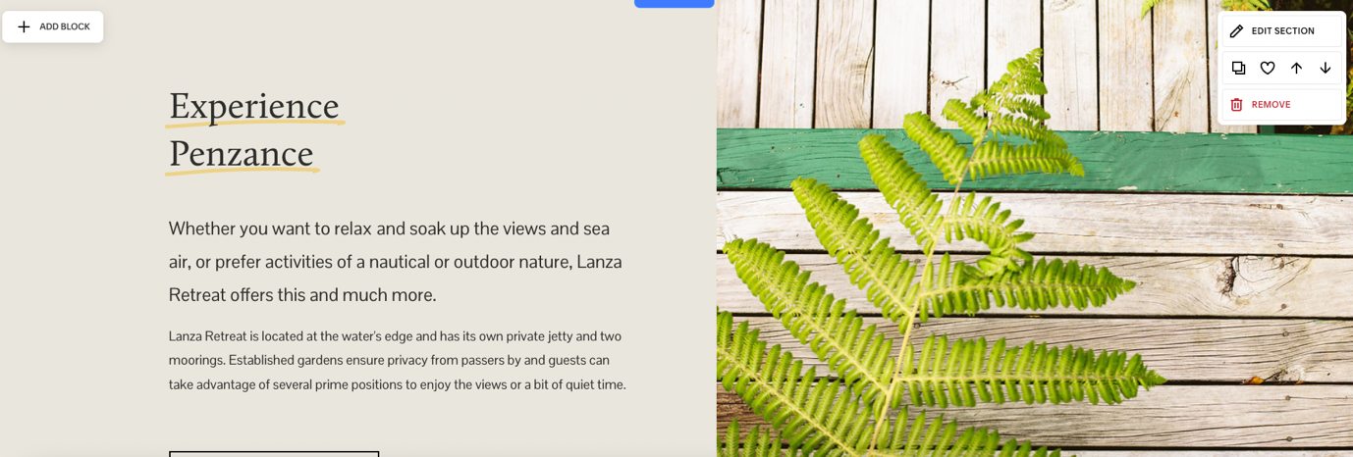
In the example above, you see other buttons, this is what they mean:
- The pencil gives you control over the section appearance. This includes section size, background, and colour.
- Clicking the two pages will duplicate everything in the section. You’ll copy the layout, any images, as well as text. Your duplicated section will immediately appear below the existing one.
- The two arrows move the section up or down the page.
- The trash can deletes the entire section.
Undo changes
1.Undo changes.
Don’t save. Press exit to undo everything you have done on that page. Press to go back one step. If you have deleted the section this will also bring back your section.
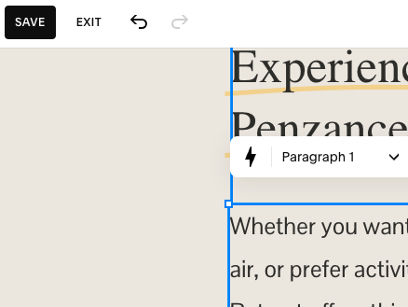
2. Trash
Accidentally deleted your page? Scroll all the way down below the navigation and you can restore a page that was in trash. After 30 days these trash pages will be automatically removed.
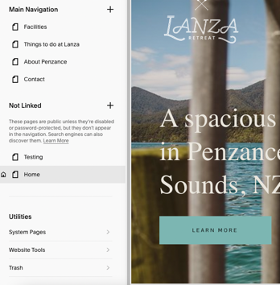
Adding Images
- Adding image in content block.
Click the image and press the pencil icon. You can change the image by clicking replace. There you can upload a file from your computer or select from library if you already have an existing image.

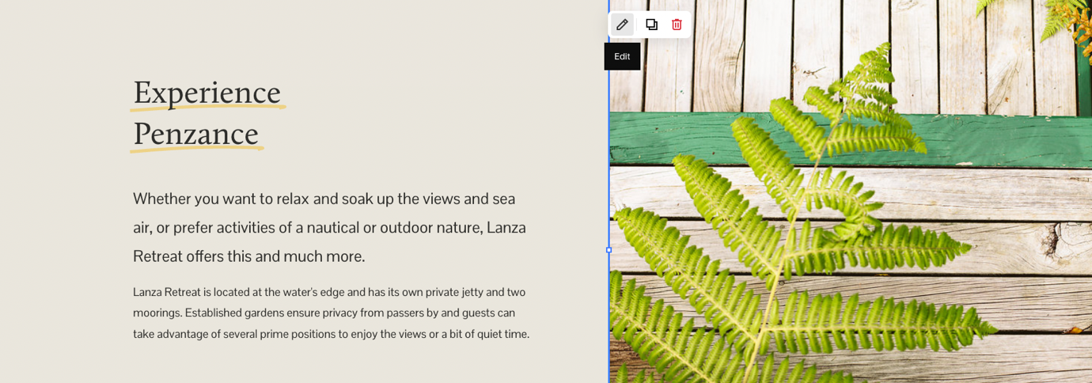

- Adding image in header
Hover over the header image until you see the edit section block. The section with the image starts below the navigation. Click edit section. Click background to change the image (see screenshot below)
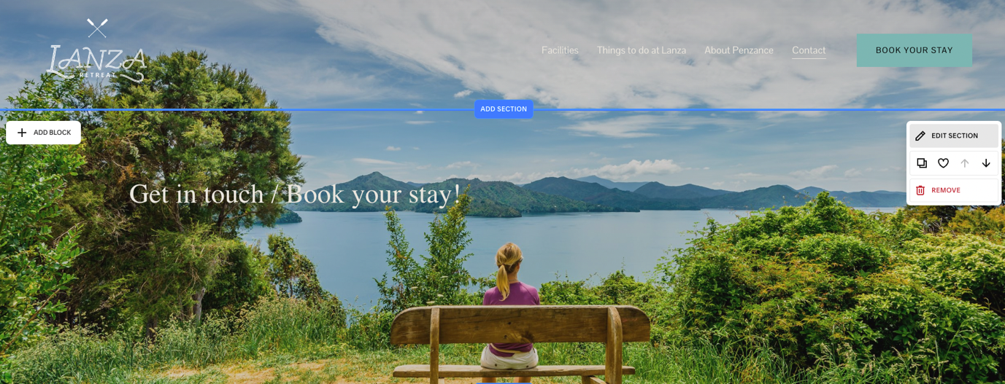

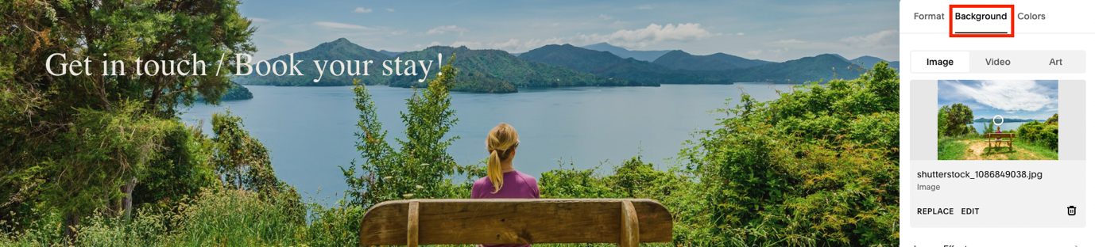

- Adding images in image gallery.
Hover over the section. Click edit section > click ‘+’ to add images.
Select images from your computer or the existing library.
To change the image order, drag the image to the right spot.
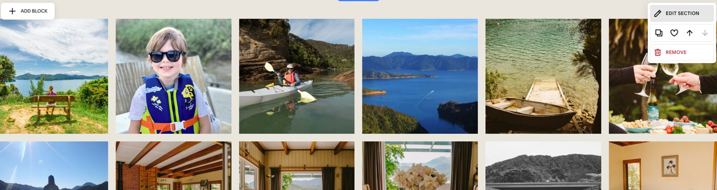
Adding Links
1. Inline link
Select the text you want to link. Click link icon > click gear icon > there you can select what type of link it is.
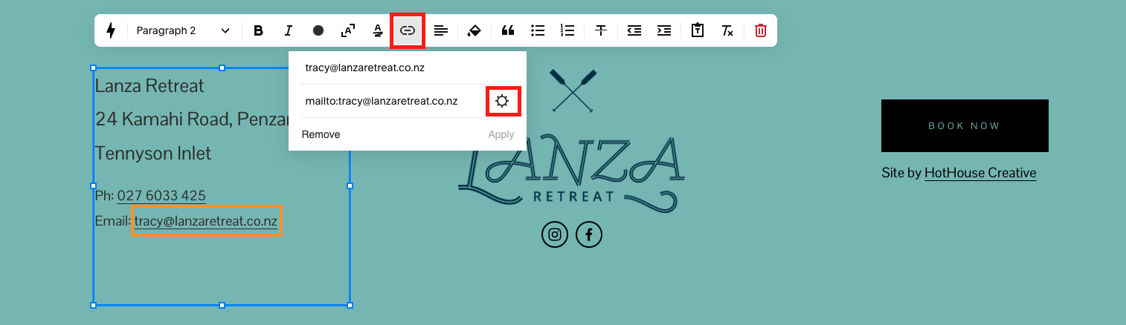
- In the example above I want to link to an email address.
- Click web address if you want to link to a external link outside the website.
- Click file to link to for instance a PDF.
- Click page to link to another page inside your website. For instance the contact page.
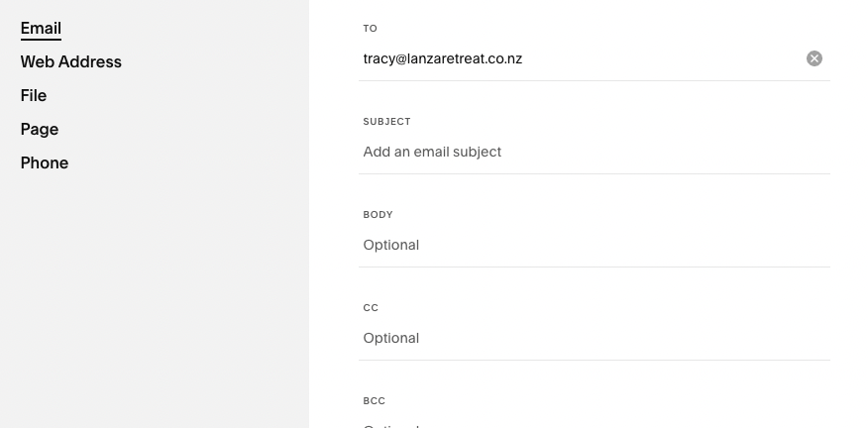
2. Button
If you hover over the section you can choose add block. You can choose button. Change text to change the button text. Click gear icon to link to a page, web address, email address, phone number or file.
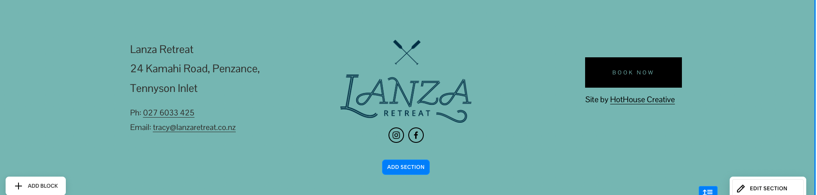

Adding sections
As we’ve been doing all the cursor rolling, you may have noticed a blue border with Add Section at opposite ends. Clicking on either of them will open the new section pop-up box containing every Squarespace section.
The easiest way is to choose a template that suits your needs.

Adding a page
You can create new pages and remove existing ones from the Website menu.
Each page in your top menu on the website can be found under the Main Navigation header. See example in red. 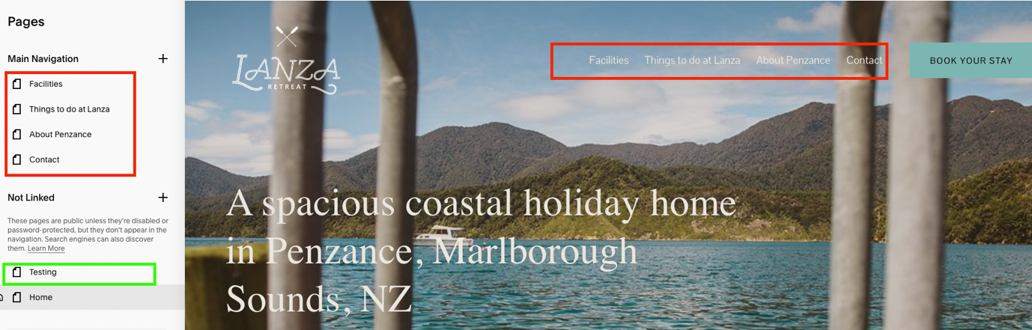
To add a page, click the “+” button according to where you’d like the page to appear.
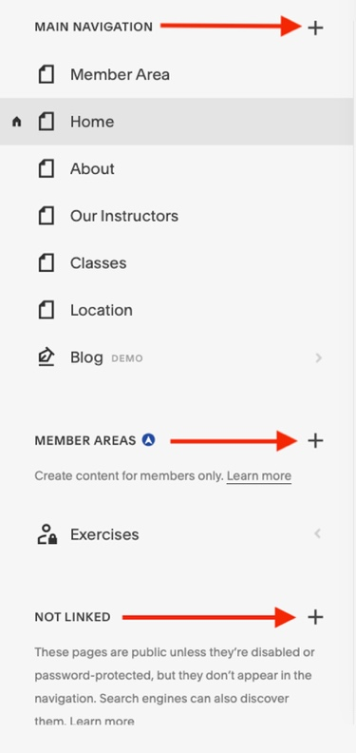

Making Duplicates and working on a page

Click on gear icon to go to the page settings > Scroll all the way down till and click duplicate page.

If you have made a duplicate of your page you’ll find the copy of the page in the unlinked pages. These pages are visible, but they are just not in the main navigation. Meaning that your page could be found in Google. Easiest way to make the page visible for you but nobody else is to go to the page settings of your copy. And click enable page. Don’t forget to make the page visible when you have moved this page to your main navigation. To move this, you can just drag the page up.

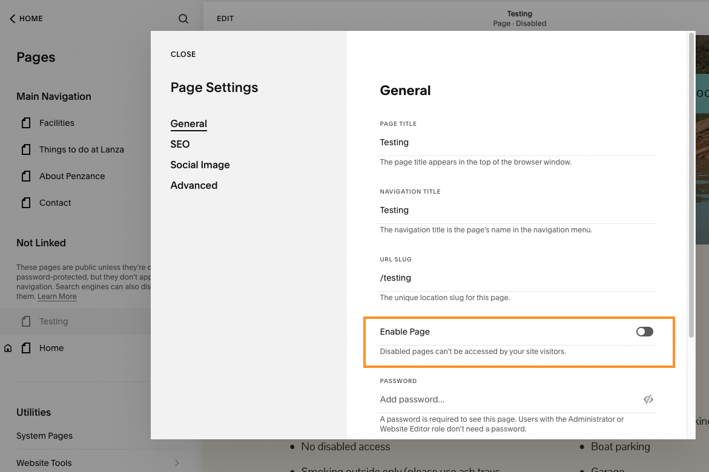

Mobile preview
When you’re happy with how your website looks, click on the phone icon in the top right corner of the editor. This is quite important to check for every page, because sometimes the layout changes on mobile. You can content blocks around, without changing the blocks on desktop.
Tip: when I have saved (published) my changes. I go to the website and check if everything looks good and works, and I check the website on my mobile phone too.
Other website options (not on every website)

Blog post
Not every website needs a blog, but it is useful when you publish something on a regular basis. If you decide to add a blog page, you can choose a layout you like and add it to the main menu. As can be seen, the menu will be updated automatically with your new page.
When you’re ready to write your first post, click on your blog page to open the archive. Once, the archive is opened click on the “+” button to start a new post.
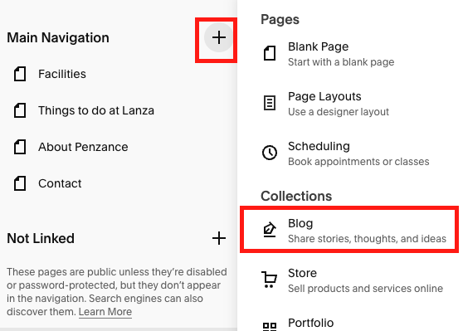
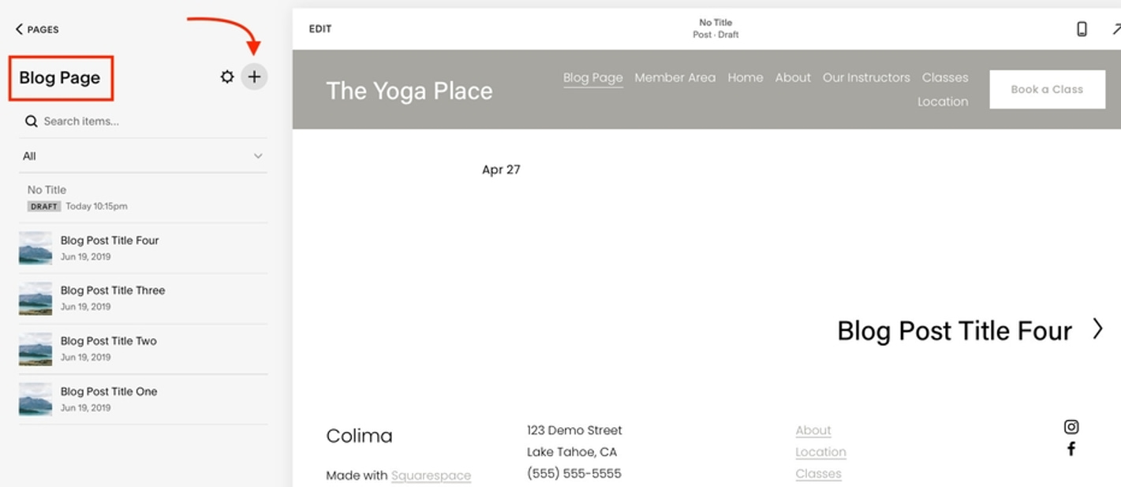

Edit blog posts
Click edit at the top of the page to change the text in the page. If you need to add a button or image, hover in between the paragraphs or below the paragraph and click on ‘+’. You can select image or add a button here.

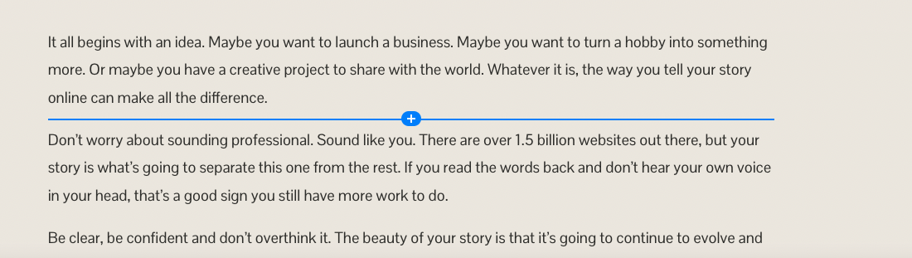

Change featured image in blog
Click ‘…’ next to the blog post. Click settings

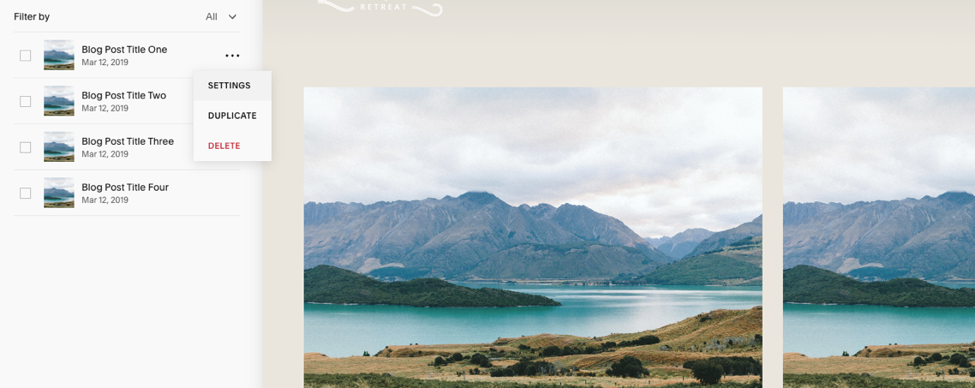
Click remove image to change the image.

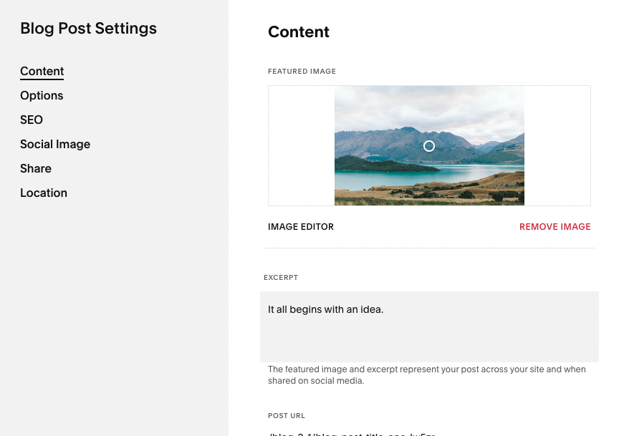

Other features in blog settings:
- Excerpt will be shown on social media shen sharing blog.
- In options you can add tags that will show under your blogpost. If you have a lot of blog posts with similar subjects, these can be clicked and all tagged subjects in your blog posts will display
- SEO you can add text and search words to optimise Google search
- Social image – add a social image here if you want to share the blogs on social media.

Accordion
To change the accordion (see screenshot, hover over the block. Click the pencil to edit. It will show the content sections here. Click ‘>’ to go to the text.

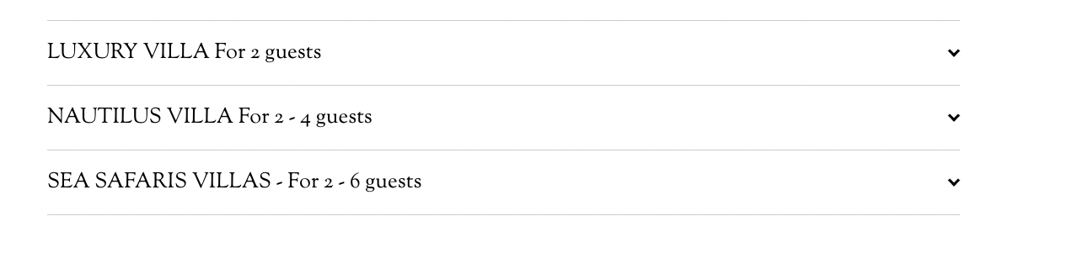

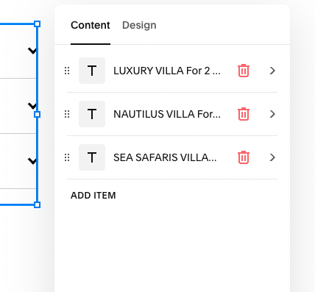

Forms
Hover over your form and click the pencil icon.
Click on Edit form fields. Here you can add fields or change fields.
In the storage tab you can change the recipient email address.
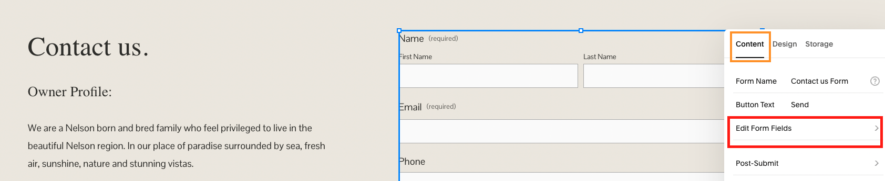

Structured items
Some sections have a template that automatically structure that particular section, like the example below. Hover over the section. Click edit Content. Go to Content tab.
Click on ‘>’ in your item to change the image or text.

